**Project Design Phase-II**

**Data Flow Diagram & User Stories**

| Date | 1 November 2023 |
| --- | --- |
| Team ID | Team-592942 |
| Project Name | Detecting COVID-19 From Chest X-Rays Using Deep Learning Techniques |
| Maximum Marks |  |

**Data Flow Diagrams:**

A Data Flow Diagram (DFD) is a traditional visual representation of the information flows within a system. A neat and clear DFD can depict the right amount of the system requirement graphically. It shows how data enters and leaves the system, what changes the information, and where data is stored.

Here is the Data Flow Diagram for Envisioning Success project

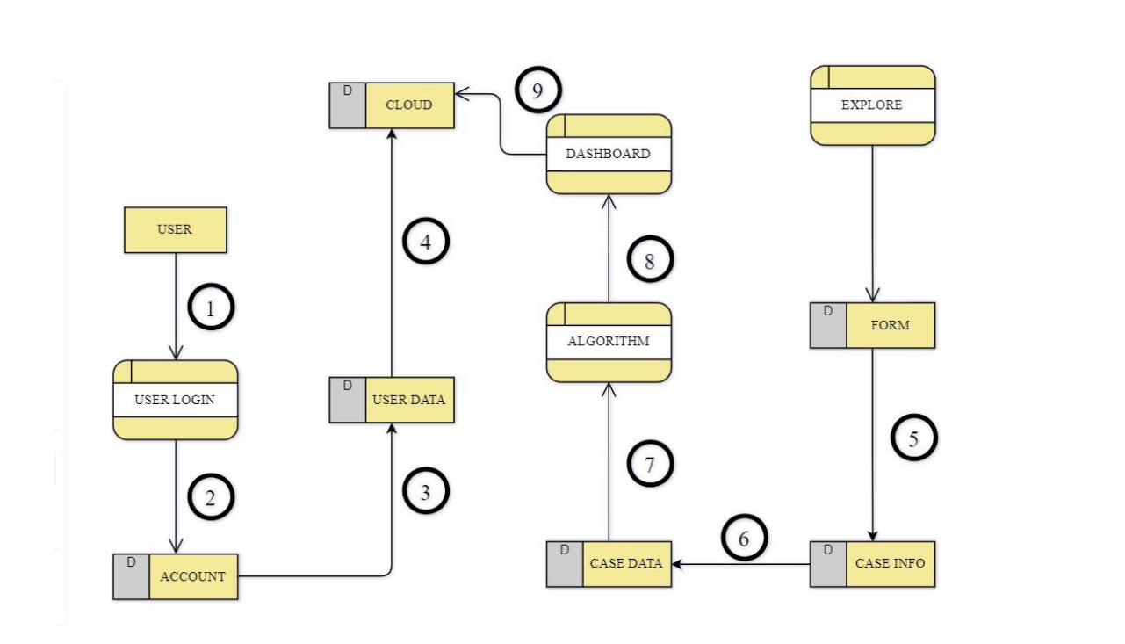

1. Users successfully complete the registration process.

2. Within the Web App's Explore section, users are prompted to input specific characteristics.

3. The provided Case Info undergoes a seamless transformation into formatted Case Data.

4. The transformed Case Data serves as input for the FetalAI algorithm.

5. The algorithm processes the data, predicts the score, and presents the results on a dynamic dashboard.

**User Stories**

Use the below template to list all the user stories for the product.

| **User Type** | **Functional**  **Requirement**  **(Epic)** | **User Story Number** | **User Story / Task** | **Acceptance criteria** | **Priority** | **Release** |
| --- | --- | --- | --- | --- | --- | --- |
| Customer | Registration | USN-1 | As web user, I can register for the application by entering my email, password, and confirming my password. | Successfully entering email, password, and confirming password leads to account creation. | High | Sprint-1 |
|  |  | USN-2 | As user, I can register for the application through smartbridge internz platform. | Successful registration and access to dashboard using smartbridge internz credentials. | Low | Sprint-2 |
|  |  | USN-4 | As a user, I can register for the application through Gmail | Successful registration and access to the FetalAI dashboard through Gmail. | Medium | Sprint-1 |
|  | Login | USN-5 | As a mobile user, I can log into the FetalAI application by entering my email and password. | Successfully entering a valid email and password leads to login. | High | Sprint-1 |
|  | Best Algorithm Finding | USN-7 | Trying out all the available algorithms in order to find which one gives the best accuracy rate | Ability to filter and sort predictions based on parameters such as gestational age, health risk levels, and other relevant factors. | High | Sprint-1 |
|  | Finding correlations | USN-8 | We have a huge number of 21 parameters which can be hectic to handle, hence we shall find correlated columns and eliminate them. | * Access a user-friendly dashboard offering comprehensive insights into health predictions for selected pregnancies. Explore predicted health parameters, receive recommendations, and view relevant data visualizations. Utilize convenient filters and sorting options based on parameters like gestationalage, health risk levels, and other relevant factors. | High | Sprint-1 |
|  | Logo requirement | USN-10 | Find or design an apt logo for the WebUI | The logo should reflect the essence of our application, conveying a sense of health,and advanced technology.  The colors used in the logo should be harmonious with the color scheme of the WebUI, promoting visual consistency. | Medium | Sprint-1 |
|  | Defining Description | USN-11 | A detailed information about the application, its uses, and its application should be available for the users in order to understand better about the model. | The information should be easily accessible within the application, preferably through a dedicated section or help center. | Medium | Sprint-2 |
| Customer Care Executive | Contact us page | USN-12 | In order to allow the users to post further queries, a contact us part of the page must be made available with the details of our team in it and how to contact us. | Include a mechanism for users to provide feedback on the "Contact Us" process, ensuring continuous improvement and addressing any issues promptly. | Medium | Sprint-3 |
|  | Back Navigator | USN-14 | A button must be provided for the users to return to the predictor_inputs page to start predicting from the model again | Use an intuitive icon or label for the button to clearly convey its purpose, ensuring users understand that clicking it will take them back to the predictor_inputs page. | Low | Sprint-4 |